DAY-8

1)

https://github.com/rvsp/typescript-oops/blob/master/Practice/Movie.md

ANSWER

class Movie{

constructor(title,studio,rating="PG")//assign value to PG if it is not assigned

{

this.title=title;

this.studio=studio;

this.rating=rating;

}

getDetails(){ //prints all the values in the object

console.log("Movie Title : "+this.title);

console.log("Studio : "+this.studio);

console.log("Rating : "+this.rating);

}

}

function getPG(arr) //get the whole array object

{

let updated_array=[];

for(let i=0;i<arr.length;i++) //flow through the whole array

{

if(arr[i].rating=="PG") //if i=the rating is PG push into the new array

{

updated_array.push(arr[i]);

}

}

console.log("UPDATED ARRAY : ")

console.log(updated_array);

}

let obj1=new Movie("Avengers","Marvel Studios","R");

let obj2=new Movie("Frozen","Walt Disney");

let obj3=new Movie("Narnia","Walt Disney");

let objects_array=[obj1,obj2,obj3];//pack all objects

obj1.getDetails();

obj2.getDetails();

obj3.getDetails();

getPG(objects_array);

OUTPUT

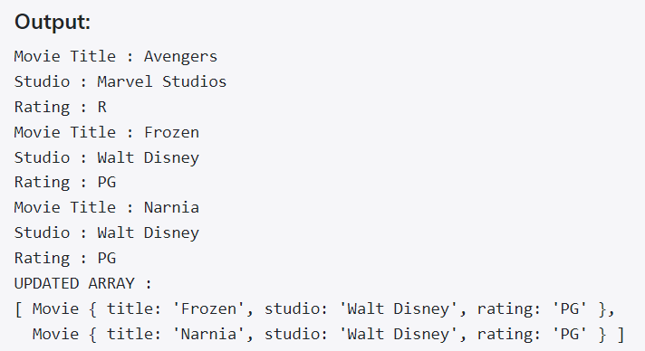

2)

https://github.com/rvsp/typescript-oops/blob/master/Practice/class-circle.md

ANSWER

class Circle{

constructor(radius=1.0,color="red")//assign the values

{

this.radius=radius;

this.color=color;

}

getRadius()//get the radius value

{

return this.radius;

}

setRadius(r)//set the radius value which is passed

{

this.radius=r;

}

getColor()//get the color value

{

return this.color;

}

setColor(c)//set the color value which is passed

{

this.color=c;

}

getArea() //calculate the area of the circle -2*pi*r*r

{

return Math.PI*(this.radius*this.radius);

}

getCircumference() //calculate the circumference of the circle - 2*pi*r

{

return 2*Math.PI*this.radius;

}

toString()

{

return `From toString \nRadius of the circle : ${this.radius} \nColor of the circle : ${this.color}`;

}

}

let obj1=new Circle();

obj1.setColor("White");

obj1.setRadius("3.5");

console.log("Radius of the circle : "+obj1.getRadius());

console.log("Color of the circle : "+obj1.getColor());

console.log("Area of the circle : "+obj1.getArea());

console.log("Circumference of the circle : "+obj1.getCircumference());

console.log(obj1.toString());

OUTPUT

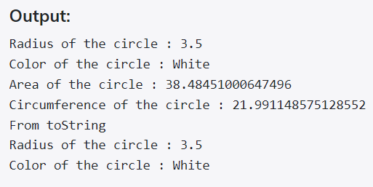

3)

Write a “person” class to hold all the details.

ANSWER

class Person{

constructor(name,age,email,phoneno,nationality,native)

{

this.name = name;

this.age = age;

this.email = email;

this.phoneno = phoneno;

this.nationality = nationality;

this.native = native;

}

getName() //get the name

{

return this.name;

}

setName(name) //set the name to Elakkiya

{

this.name=name;

}

getAge() //get the age

{

return this.age;

}

setAge(age) //set the age to 21

{

this.age=age;

}

getEmail()

{

return this.email;

}

setEmail(email)

{

this.email=email;

}

getPhoneno()

{

return this.phoneNo;

}

setPhoneno(phoneno)

{

this.phoneNo=phoneno;

}

getnationality()

{

return this.nationality;

}

setnationality(nationality)

{

this.nationality=nationality;

}

getnative()

{

return this.native;

}

setnative(native)

{

this.native=native;

}

}

let obj1=new Person(); //object creation

//set all the values name,age,email,phoneno,nationality,native

obj1.setName("Elakkiya");

obj1.setAge("21");

obj1.setEmail("elakia@gmail.com");

obj1.setPhoneno("8610090000");

obj1.setnationality("India");

obj1.setnative("Madurai")

console.log("Name : "+obj1.getName());

console.log("Age : "+obj1.getAge());

console.log("Email: "+obj1.getEmail());

console.log("Phoneno : "+obj1.getPhoneno());

console.log("Nationality : "+obj1.getnationality());

console.log("Native : "+obj1.native);

OUTPUT

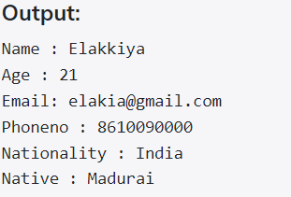

4)

write a class to calculate uber price.

ANSWER

class Car{

constructor(kms,min)

{

this.kms=kms;

this.min=min;

this.cost_per_min = 1.5;

this.cost_per_km = 0;

this.base_far = 10;

this.booking_fee = 20;

this.total_amount = 0;

}

//calculation is differ for <20 km and >20km

//basefee+(costpermin*min)+(costtperkm*km)+bookingfee

CalculateAmount()

{

if(this.kms <= 20)

{

this.cost_per_km = 6;

this.total_amount = this.base_far+(this.cost_per_min*this.min)+(this.cost_per_km*this.kms)+this.booking_fee;

}

else if(this.kms > 20)

{

this.cost_per_km = 12;

this.total_amount = this.base_far+(this.cost_per_min*this.min)+(this.cost_per_km*this.kms)+this.booking_fee;

}

console.log("Total Amount : " + this.total_amount);

}

}

let obj1 = new Car(15,20)

let obj2 = new Car(25,50)

obj1.CalculateAmount();

obj2.CalculateAmount();

OUTPUT

